CENWP-OD-B 18 August 2024

MEMORANDUM FOR THE RECORD

SUBJECT: 24BON045 MFR CI LPS Pond Pacific Lamprey Mortality

On the morning of 18 August, Project Biologists discovered one Pacific Lamprey mortality in the Cascades Island LPS pond (CI LPS Pond). The fish was scanned for PIT tags, measured, inspected, and was placed in the AFF freezer for genetics analysis by CRITFC.

- Species – Pacific Lamprey (Entosphenus tridentatus)
- Origin – Unknown.
- Length – 34.93cm
- Marks and tags – None.
- Marks and Injuries found on carcass – None.
- Cause and Time of Death – Unknown.
- Future and Preventative Measures – None.

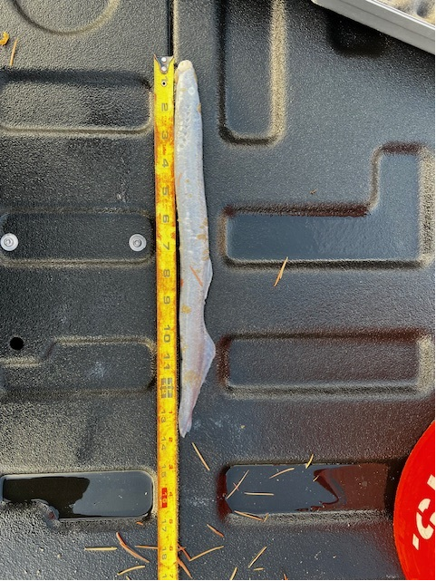

Sincerely,
Bonneville Project Fisheries

